
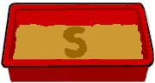

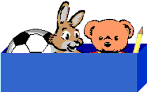
Cleobury Mortimer Primary School

Learning to read through play

Letters and Sounds

Promoting Partnership between home, school and the community

Making Sentences
Read the book with your child so he/she is familiar with the story. Then simply use the first sentence from the reading book and copy it out on a strip of paper. Either write it out or if you use a word processor use a font such as Century Gothic (font size 36 at least). Leave a double space in between each word. Now cut up the sentence into the individual words. For example:

Ask your child to make the sentence, "This is a dog.", using the individual words. At first you will probably need to help. When he/she has made the sentence ask your child to read it to you and encourage him/her to point to each word with a finger.

Retain interest by only spending a few minutes a day on the activity. If your child makes a mistake do not say "That's wrong" immediately, because negative comments discourage. Ask your child to read the sentence and mistakes will often be self-corrected. If not, you can give clues such as, "What sound does dog start with?" If your child is still unable to read it, say positive comments such as "What a good try. You got all these right and only this part wrong. Well done." Then show your child the correct order.

We recommend working on a maximum of five sentences on each reading book.

If you require further information or advice please do not hesitate to contact your child’s class teacher.

'What does it start with?' Box
You will need:
- A box
- Several items each beginning with a different sound
- Corresponding letter cards

This game is similar to the common objects game on the previous page, but the emphasis now is on recognising the sounds the letters make. Ask your child to choose an object from the box, to think what its first sound is (remember it is the sound you are looking for rather than the alphabet name) and then to match the object with the relevant card.

Sand Tray or Finger Paints
Children enjoy writing letters with their fingers in a tray of sand or with finger paints. These ways provide good opportunities to teach correct letter formation.

Sentence Games

This activity is quite useful when your child has been given an early reading book. Quite often parents say "He's not reading the book. He's remembering the story off by heart". This can happen. Some children become over-dependent on the picture clues and do not look for clues from the words.

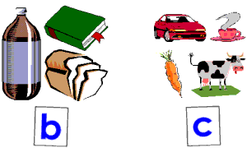
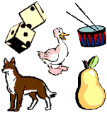
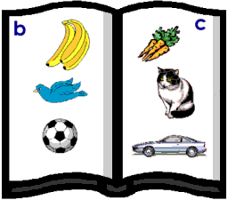
Which starts with a different
sound to the others?

Sounds Scrapbook
Write a letter at the top of each page of a scrapbook. Concentrating on a few letters at a time collect pictures of objects that begin with those letters. Do not use as examples words where the first sound does not make its normal sound such as in giraffe, ship, cheese, thumb. Stick the pictures on the appropriate pages.

Games For Recognising Letter Shapes…

Fishing for Sounds
You will need a few cards with individual letters. Attach a paper clip to each card. Using a small stick with a string and magnet, your child fishes for letter sounds. If your child can say the sound of the letter he/she wins the card, otherwise you win it.

Sequencing the Letters in your Child's Name
Providing the individual letter cards for each letter of your child's first name can be a useful way to teach the sequence of letters. Remember you will need to write a capital for the first letter and lower case for the rest.

If you want to print out the cards using a word processor use a font such as Century Gothic on PC which has not a. Show your child how to make the name first, before shuffling the cards for him/her to have a try. For a very long name work with the first few and build up a letter at a time.

Sound Games to Play at Home…

Common Objects
Collect several objects that begin with the same sound and make a card with this letter sound on it. Make a second group of objects beginning with a different sound and a card to go with those.

Discuss the sounds of the letters on the two cards with your child and shuffle the objects. Separate the cards on the floor and ask your child to put each object near the sound that it starts with. This activity can help your child to "hear" the first sound of a word.

Odd-one Out
Say a number of words, all but one of which begin with the same sound. See if your child can pick out the odd one. It can be helpful to have the corresponding objects there for the child to look at.

I-Spy
For small children the usual way of playing that starts 'I spy with my little eye something that begins with ....' can be too difficult. You can make this easier by providing a clue. 'I spy with my little eye something that barks and begins with d'.

Why begin Teaching Reading through Games?

It is vital that early reading experiences are happy and positive. The aim should be not just for children to learn to read, but to enjoy reading. Whilst games may appear to be an indirect approach, they do protect a child from a feeling of failure. By 'playing together' both parent and child are relaxed. Where a child could feel pressured in a formal teaching situation he/she will usually enjoy reading activities in a 'play' situation. This leaflet aims to give you simple ideas to try.

The Sounds of Letters

Tips for teaching your child the sounds:

- It is important for a child to learn lower case or small letters rather than capital letters at first. Most early books and games use lower case letters and your child will learn these first at school. Obviously you should use a capital letter when required, such as at the beginning of the child's name, eg. Paul.

- When you talk about letters to your child, remember to use the letter sounds: a buh cuh duh e ... rather than the alphabet names of the letters: ay bee see dee ee . The reason for this is that sounding out words is practically impossible if you use the alphabet names. eg. cat, would sound like: see ay tee

- When saying the sounds of b, d, g, j and w you will notice the 'uh' sound which follows each, for example buh, duh... You cannot say the sound without it, however, try to emphasise the main letter sound.

