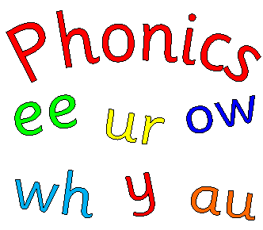

Phonics information for parents and carers.

Ways you can support your children at home: talking and listening
Make time to listen to your child talking – as you meet them from their setting or school, as you walk, or travel home by car, in the supermarket as you shop, at meal times, bath times, bedtimes – any time!
Switch off the TV, radio and mobile phones – and really listen!
Show that you are interested in what they are talking about – look at your child, smile, nod your head, ask a question or make a response to show that you really have been listening.

Make a collection of different toy creatures – for example, a duck, a snake, an alien, say the sound it might make as you play together, for example, ‘quack-quack’, ‘ssssssss’, ‘yuk-yuk’, and encourage your child to copy you.

Listen at home – switch off the TV and listen to the sounds, both inside and outside the home. Can your child tell you what sounds they heard, in the order in which they heard them?
Play-a-tune – and follow me! Make or buy some simple shakers, drums and beaters, then play a simple tune and ask your child to copy. Have fun!

Use puppets and toys to make up stories or retell known ones. Record your child telling the story and play it back to them.

Sounds in spoken language – the beginning of phonics

At Cleobury Mortimer Primary School, when children enter the Reception class they take part in high-quality phonics sessions every day. These are fun sessions involving lots of speaking, listening and games, where the emphasis is on children’s active participation. They learn to use their phonic knowledge for reading and writing activities and in their independent play. The aim of this booklet is to give you a clear picture of how we approach the teaching of phonics and word recognition and how, as a parent or carer, you can support and encourage your child at home. Not all children will learn at the same rate! Your child should be supported whatever their rate of learning. There is a very close link between difficulty with phonics and hearing so, if your child is making progress more slowly than might be expected, it would be worth having their hearing checked. From a very early stage, children develop awareness of different sounds in spoken language. They develop understanding that spoken words are made up of different sounds (phonemes) and they learn to match these phonemes to letters (graphemes). Phonics is about children knowing how letters link to sounds (graphemes to phonemes), for example, c as in ‘cat’, ll as in ‘fell’, ee as in ‘sheep’. Children use this phonic knowledge when they are reading and writing. This approach has been shown to provide a quick and efficient way for most young children to learn to read words on the page, fluently and accurately. We want children to develop this skill so that it becomes automatic. This also greatly helps them with their spelling.

At Cleobury Mortimer Primary school we use a systematic phonics programme called Letters and Sounds alongside Oxford Reading tree and RWI reading schemes. Letters and Sounds is divided into six phases, with each phase building on the skills and knowledge of previous learning. There are no big leaps in learning. Children have time to practise and rapidly expand their ability to read and spell words. They are also taught to read and spell ‘tricky words’, which are words with spellings that are unusual or that children have not yet been taught.

Phase 1, 3 - 4 years old

This paves the way for systematic learning of phonics and usually starts in nursery or playgroup. Teachers plan activities that will help children to listen attentively to sounds around them, such as the sounds of their toys and to sounds in spoken language. Teachers teach a wide range of nursery rhymes and songs. They read good books to and with the children. This helps to increase the number of words they know – their vocabulary – and helps them talk confidently about books.

Learning how to ‘sound-talk’
The teacher shows children how to do this – c-a-t = cat. The separate sounds (phonemes) are spoken aloud, in order, all through the word, and are then merged together into the whole word. The merging together is called blending and is a vital skill for reading. Children will also learn to do this the other way around – cat = c-a-t. The whole word is spoken aloud and then broken up into its sounds (phonemes) in order, all through the word. This is called segmenting and is a vital skill for spelling. This is all oral (spoken). Your child will not be expected to match the letter to the sound at this stage. The emphasis is on helping children to hear the separate sounds in words and to create spoken sounds.

Ways you can support your children at home
Sound-talking
Find real objects around your home that have three phonemes (sounds) and practise ‘sound talk’. First, just let them listen, then see if they will join in, for example, saying:
‘I spy a p-e-g – peg.’
‘I spy a c-u-p – cup.’
‘Where’s your other s-o-ck – sock?’
‘Simon says – put your hands on your h-ea-d.’
‘Simon says – touch your ch-i-n.’
‘Simon says – pick up your b-a-g.’

Phase 2, 4 – 5 years old
In this phase children will continue practising what they have learned from phase 1, including ‘sound-talk’. They will also be taught the phonemes (sounds) for a number of letters (graphemes), which phoneme is represented by which grapheme and that a phoneme can be represented by more than one letter, for example, ‘ll’ as in b-e-ll. They may be using pictures or hand movements to help them remember these.

VC and CVC words

C and V are abbreviations for ‘consonant’ and ‘vowel’. VC words are words consisting of a vowel then a consonant (e.g. am, at, it) and CVC words are words consisting of a consonant then a vowel then a consonant (e.g. cat, rug, sun). Words such as tick and bell also count as CVC words – although they have four letters, they have only three sounds.

For example, in the word bell, b = consonant, e = vowel, ll = consonant.

Now the children will be seeing letters and words, as well as hearing them. They will be shown how to make whole words by pushing magnetic or wooden letters together to form little words, reading little words on the interactive whiteboard and breaking up words into individual sounds, which will help their spelling. These will be simple words made up of two phonemes, for example, am, at, it, or three phonemes, for example, cat, rug, sun, tick, bell.

Tricky words
They will also learn several tricky words: the, to, I, go, no. Children will still be practising oral blending and segmenting skills daily. They need plenty of practice at doing this.

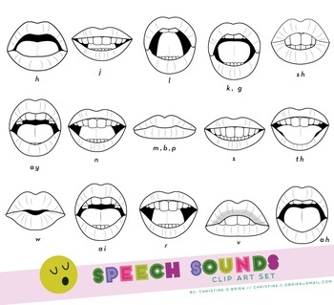
Saying the sounds
Your child will be taught how to pronounce the sounds (phonemes) correctly to make blending easier. Sounds should be sustained where possible (e.g. sss, fff, mmm) and, where this is not possible, ‘uh’ sounds after consonants should be reduced as far as possible (e.g. try to avoid saying ‘buh’, ‘cuh’). Teachers help children to look at different letters and say the right sounds for them. (Please see the attached sheet which will help you with the correct pronunciation of the phonemes).

Getting ready for writing
Teachers will model how to form letters (graphemes) correctly, so that children can eventually acquire a fluent and legible handwriting style. These skills develop over a long period of time. A child’s ability to form a letter correctly is a separate skill from phonics. Holding a pen or pencil needs considerable co-ordination and practice in making small movements with hands and fingers. In the early phonic phases children can use letter cards or magnetic letters to demonstrate their knowledge of phonics.

Writing in lower-case letters
We shall be teaching lower-case letters, as well as capital letters. As most writing will be in lower-case letters it is useful if you can use these at home. A good start is for your child to write their name correctly, starting with a capital letter followed by lower-case letters. (Please see the attached letter formation sheet for the schools style of hand writing that is taught)
Phase 3, 4 – 5 years old
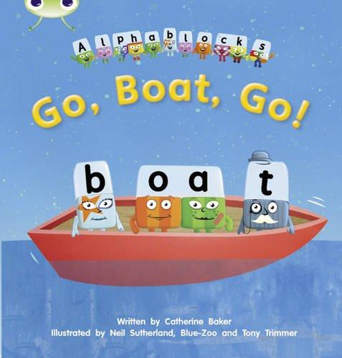
The purpose of this phase is to:
• teach more graphemes, most of which are made of two letters, for example, ‘oa’ as in boat
• practise blending and segmenting a wider set of CVC words, for example, fizz, chip, sheep, light
• learn all letter names and begin to form them correctly
• read more tricky words and begin to spell some of them
• read and write words in phrases and sentences.

CVC words containing graphemes made of two or more letters
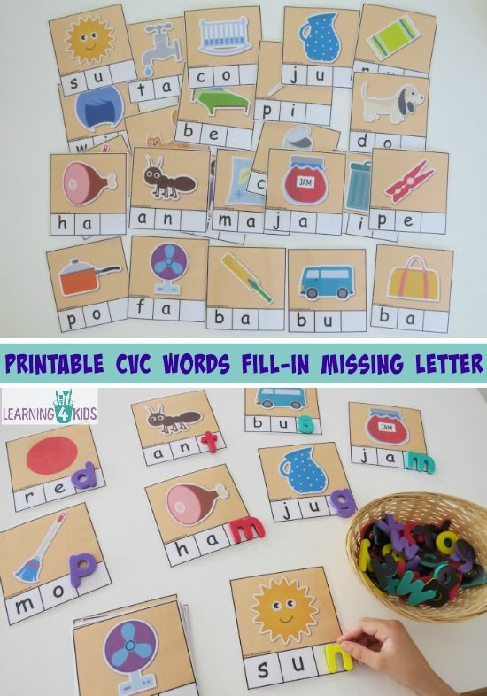
Here are some examples of words your children will be reading: tail, week, right, soap, food, park, burn, cord, town, soil Their confidence from the daily experience of practising and applying their phonic knowledge to reading and writing is really paying off! Tricky words The number of tricky words is growing. These are so important for reading and spelling: he, she, we, me, be, was, my, you, her, they, all.

Phase 4, 5 – 6 years old
Children continue to practise previously learned graphemes and phonemes and learn how to read and write:
CVCC words: tent, damp, toast, chimp

For example, in the word ‘toast’, t = consonant, oa = vowel, s = consonant, t = consonant.

CCVC words: swim, plum, sport, cream, spoon

For example, in the word ‘cream’, c = consonant, r = consonant, ea = vowel, m = consonant.

They will be learning more tricky words and continuing to read and write sentences together.

Tricky words
said, so, do, have, like, some, come, were, there, little, one, when, out, what

Phase 5, 6 – 7 years old
In phase 5 children will:
Be taught further graphemes for reading.
Be taught alternative pronunciations for graphemes.
Be taught alternative spellings for phonemes.
Recognise graphemes in reading words.
Practice reading and spelling of high-frequency (common) words.
Practice reading and spelling two-syllable and three-syllable words.
Practice reading and writing sentences.

Children entering Phase Five are able to read and spell words containing adjacent consonants and some polysyllabic words.


The purpose of this phase is for children to broaden their knowledge of graphemes and phonemes for use in reading and spelling. They will learn new graphemes and alternative pronunciations for these and graphemes they already know, where relevant. Some of the alternatives will already have been encountered in the high-frequency words that have been taught. Children become quicker at recognising graphemes of more than one letter in words and at blending the phonemes they represent. When spelling words they will learn to choose the appropriate graphemes to represent phonemes and begin to build word-specific knowledge of the spellings of words.

For example;
Learn new phoneme ‘zh’ in words such as treasure.
Teach reading the words oh, their, people, Mr, Mrs, looked, called, asked.
Teach spelling the words said, so, have, like, some, come, were, there.
Teach reading the words water, where, who, again, thought, through, work, mouse, many, laughed, because, different, any, eyes, friends, once, please.
Teach spelling the words little, one, do, when, what, out.
Teach spelling the words oh, their, people, Mr, Mrs, looked, called, asked.

Phase 6, 6 - 7 years old

In phase 6 children will:
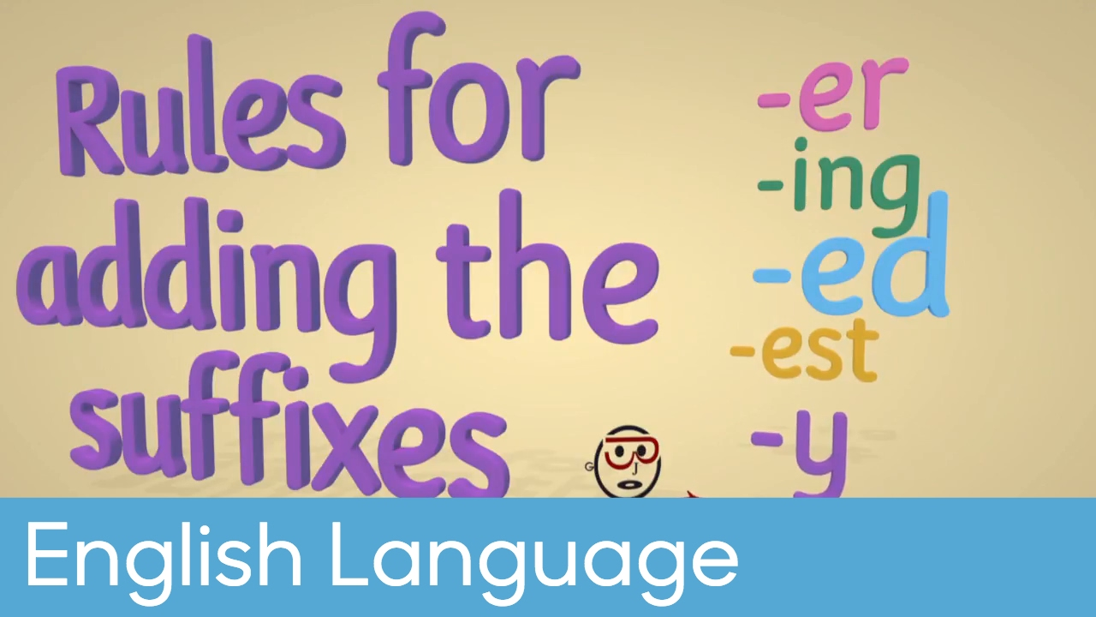
Be introduced to and taught the past tense.
Investigate and learn how to add suffixes.
Be taught how to spell long words.
Be taught how to find and learn the difficult bits in words.
Learn and practice spellings.

For example;
The past tense dealt with in this section is simple past tense, e.g. I looked, not continuous past tense, e.g. I was looking.
To reinforce understanding and application of the -ed suffix for the past tense (e.g. rounded, helped, turned, begged, hissed, wanted, sorted, hummed, waded, washed, hated, greased, lived)

Strategies Explanations
1. Syllables To learn my word I can listen to how many syllables there are so I can break it into smaller bits to remember (e.g. Sep-tem-ber, ba-by)
2. Base words To learn my word I can find its base word (e.g. Smiling – base smile +ing, e.g. women = wo + men)
3. Analogy To learn my word I can use words that I already know to help me (e.g. could: would, should)
4. Mnemonics To learn my word I can make up a sentence to help me remember it (e.g. could – O U Lucky Duck; people – people eat orange peel like elephants)
5. Rainbow write- To write the word using different colours.

Order in which phonemes are introduced in ‘Letters and Sounds’

Phase 1 Seven Aspects: Three strands in each
1) tuning in to sounds
2) listening and remembering sounds
3) talking about sounds
Oral segmenting and blending introduced in Aspect 7 Continues through all Phases

Phase 2
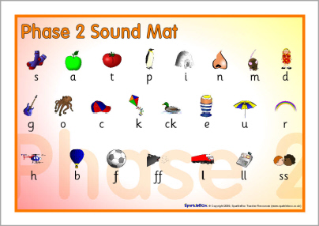
Phase 3
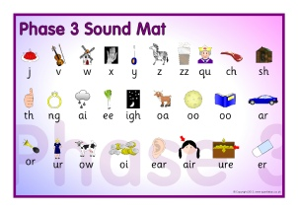
Phase 4
No new graphemes Consolidation of above to read and spell words containing adjacent consonants and to read and spell polysyllabic words-segmenting to spell, blending to read

Phase 5
New graphemes, alternative pronunciations for those already known and alternative
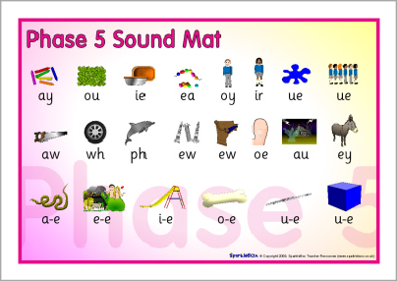
spellings for phonemes

Phase 6
Consolidation of all of the above sounds-
Children apply skills and knowledge learned above to become fluent readers and increasingly accurate spellers. Past tense words Adding Suffixes/prefixes to make longer words Tricky ‘bits’ in words and use of memory strategies-

